HOW TO SET ADOBE READER AS DEFAULT FOR PDF FILES

- Click on the “Start” menu and type “Default”. Click on the “Default apps” selection that appears.

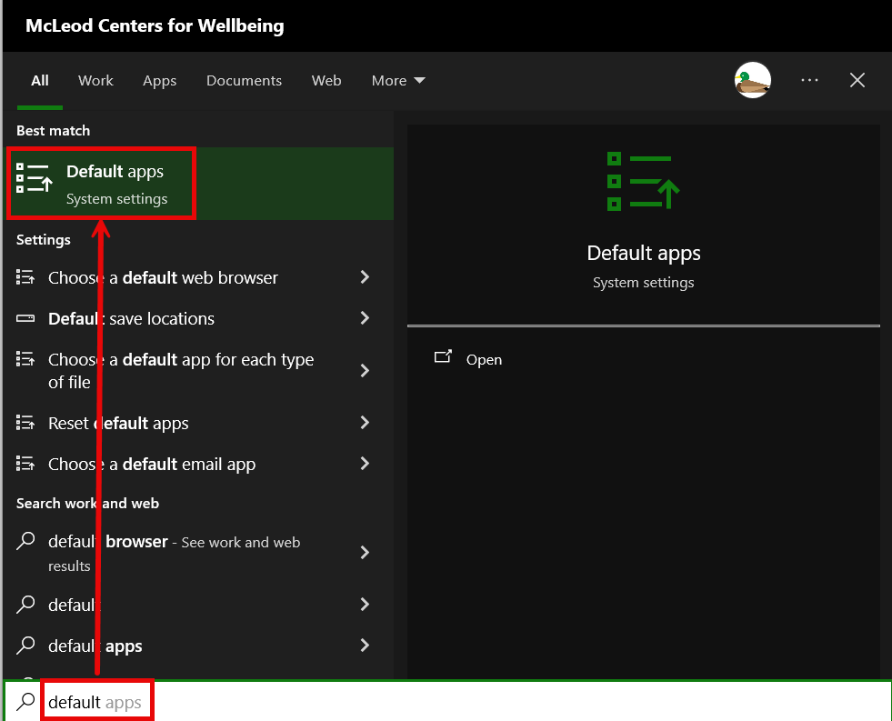

- On the “Default apps” window that appears, scroll down to the bottom and select the “Choose default apps by file type” option.
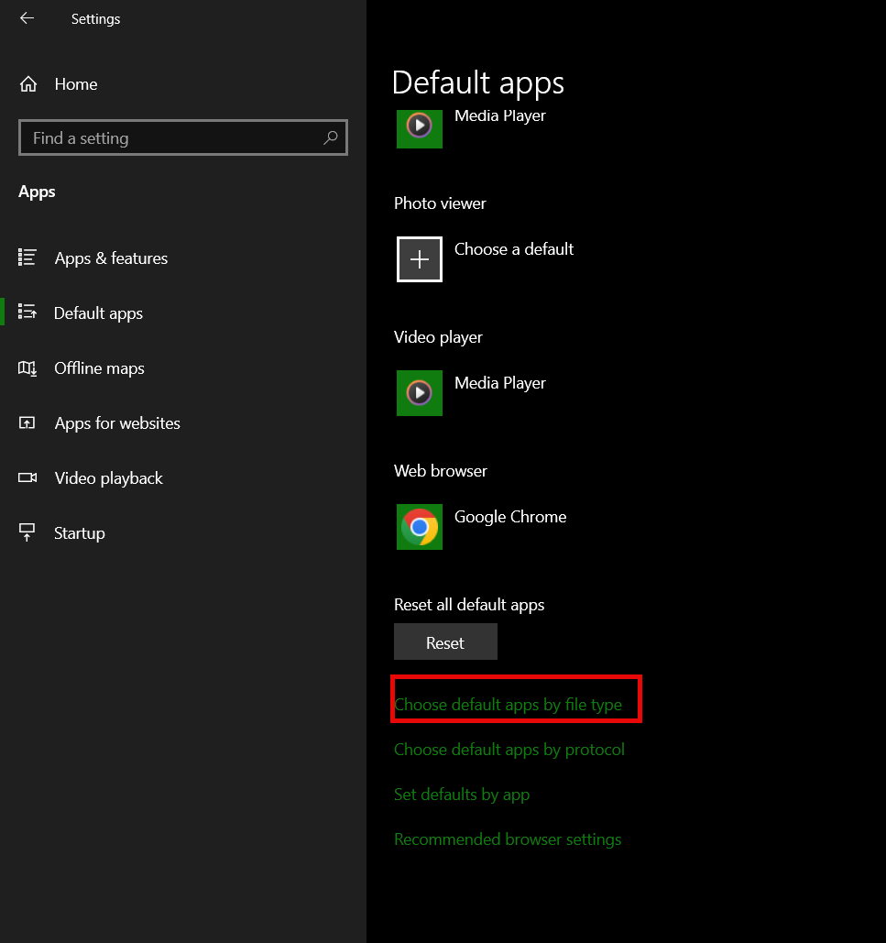

- After the next window loads, scroll down to the listing titled “.pdf”, click on the “Microsoft Edge” button, and select “Adobe Acrobat”. This will change the default to Adobe.
